**Selenium Python Guru99 Insurance application testAutomation**

1. install python 3 and select or configure project intrepeter

2. Install selenium web driver --> go to setting and add selenium, pytest, pytest-allure

step: Setting --> Project Intrepeter --> Add Packates --> Search required packages and install.

required packages -- Pytest, allure, Faker, random, selenium webdriver - wait,

to install via terminal -- enter following commands,

pip install selenium

pip install pytest

pip install faker

**Project Structure :**

PageObject (Package) --> contains the page locater element and action method to manupute these elements.

test (packages) ---> contains testcase

TestData (Directory) --> includes testdata files

utilHelper(Package) --> includes common helper files such as logger, excel reader,

**To run project -->**

goto terminal and enter >> pytest -v -s .\testCases\test_guru99_insurance.py --html=.\Reports\report.html

--html=.\Reports\report.html ---> this will generate Test Report in HTML format at Report directory with file name report.html

.\testCases\test_guru99_insurance.py ---> Testcase directory and test case name that we are going to execute.

to generate allure report add we can use --alluredir=Allure_Reports commands while running a testcase.

this will generate allure report in Directory Allure_Reports .

to view report, to to Allure_Reports directory and run command >> allure serve

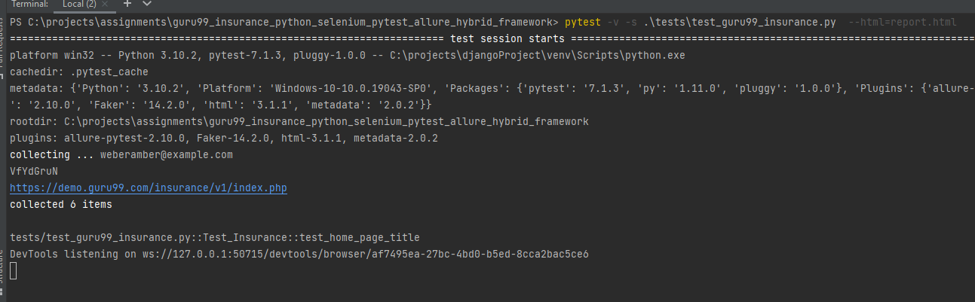

C:......>allure serve C:..\guru99_insurance_python_selenium_pytest_allure_hybrid_framework\allure-report

